Background
During Summer 2018, the Forest Stewardship Council (FSC) US hosted two webinars and three regional meetings to help identify practical actions that companies can take to reduce the risk of procuring wood from forests where important ecological values are threatened. These meetings constitute one part of FSC’s revised approach to Controlled Wood, and will provide companies that source Controlled Wood from the conterminous Untied States with the information they need to mitigate the risks that are identified in the FSC US Controlled Wood National Risk Assessment.
Participants included companies that are FSC certified and source Controlled Wood, their suppliers, Certification Bodies (auditors) and other stakeholders actively working to advance responsible forest management and enhance local economic development.
The three in-person regional meetings – held in Asheville, North Carolina; Atlanta, Georgia; and Portland, Oregon – focused on regionally specific set of risk topics, and were professionally facilitated to ensure efficiency, fairness, and clarity of stakeholder input.
At the regional meetings and through an online discussion forum, participants provided input on: a) proposed mitigation options for each of the risk topics; and b) shared criteria to be used as a lens for evaluating the mitigation options. This input has been used to finalize the criteria and further develop the sets of mitigation options.
During this final two-week consultation, we are requesting additional feedback on the sets of mitigation options for each risk topic. All interested and affected stakeholders are invited to participate.

Methodology for Incorporating Regional Meeting Input
For each respective risk topic, FSC US staff completed the following 4 steps:
- Thorough review of all input received during meetings, as well as individual written comments submitted on the draft mitigation options handouts and through email after the meetings, and via the online discussion forum.
- Identification of central themes (Annex A), in accordance with frequency of comments/inputs, and summarization of the input for those themes.
- Evaluation of the topline inputs in light of the shared criteria, in order to determine whether a proposed mitigation option should be kept, dropped or adapted. Any proposed new options were also evaluated in light of the shared criteria, and kept, dropped or adapted as deemed appropriate.
- Evaluation of the resulting set of mitigation options, through the lens of the shared criteria, to identify any gaps in the final set of options.

Mitigation Option Criteria
The following are the final refined shared criteria that were adapted from meeting to meeting to reflect the input received.

(No priority intended by numbers, just for reference)
- For each mitigation option, at least one of the following applies:
  - Results in decreased negative impact(s) and/or increased positive impacts from forest management activities within the specified risk area
  - Improves knowledge about how, and places where, the conservation value is being threatened within the specified risk area so that those places are avoided or mitigated; limited to situations where there is an explicit need for this specific information to improve conservation of and mitigation associated with the value
  - Promotes, expands or improves an ongoing initiative/program that is already producing verifiable positive outcomes within the specified risk area
  - Implements a new/innovative initiative/program that will fill a gap or address a weakness in the existing network of initiatives/programs associated with forest management impacts on the value in within the specified risk area.
  - Promotes, expands or improves implementation of actions within the specified risk area identified through diverse-stakeholder planning processes (e.g., State Wildlife Action Plans, regional conservation plans, Federal recovery plans)
- For each mitigation option, all of the following apply:
  - Proven or a reasonable expectation of effectiveness in maintaining or enhancing the conservation value within the specified risk area
  - Passes through topline filters of efficacy, clarity, efficiency, practicality, measurability and auditability
  - Doesn’t require companies to make extensive investments to infrastructure/resources, but will require engagement across chambers
- For the set of mitigation options, all of the following apply:
  - Provides a workable option for all enterprises, regardless of size or location in the supply chain
  - Doesn’t require certificate holders to have knowledge of specific sites from which their forest materials originate, in situations where the procurement processes and/or antitrust concerns make this information inaccessible.
  - Differentiates requirements between companies that buy directly from the forest, and those that don’t

Proposed Impact Matrix
The following is proposed as a framework for assisting Certificate Holders and Certification Bodies (auditors) with determining which mitigation options the Certificate Holder should implement and the expected scale of implementation (when a mitigation option is scalable), and then for assessing the adequacy of mitigation implemented. FSC US will work closely with Certification Bodies in the application of this matrix and ensuring consistency in auditing.
The proposed matrix is based upon the potential impact that a company’s activities might have on a conservation value, considering the proportion of the specified risk area that overlaps with the company’s supply area, and the overall size of the company (using AAF as a standardized proxy).
We are open to alternative suggestions for how to assist Certificate Holders and Certification Bodies with making these decisions and assessments.
Table 1. Proposed Impact Matrix
AAF Class | % Specified Risk Area within Supply Area
 | <25% | 25-50% | 50-75% | >75%
Class 1 | LOW | LOW | LOW | LOW
Class 2 | LOW | LOW | LOW | LOW
Class 3 | LOW | LOW | LOW | MED
Class 4 | LOW | LOW | LOW | MED
Class 5 | LOW | LOW | MED | MED
Class 6 | LOW | LOW | MED | MED
Class 7 | LOW | MED | MED | MED
Class 8 | LOW | MED | MED | HIGH
Class 9 | MED | MED | HIGH | HIGH
Class 10 | MED | HIGH | HIGH | HIGH
Class 10+ | MED | HIGH | HIGH | HIGH

Table 2. AAF Classes, as defined in the FSC AAF Policy (FSC-POL-20-005 V2-5, Table 2)
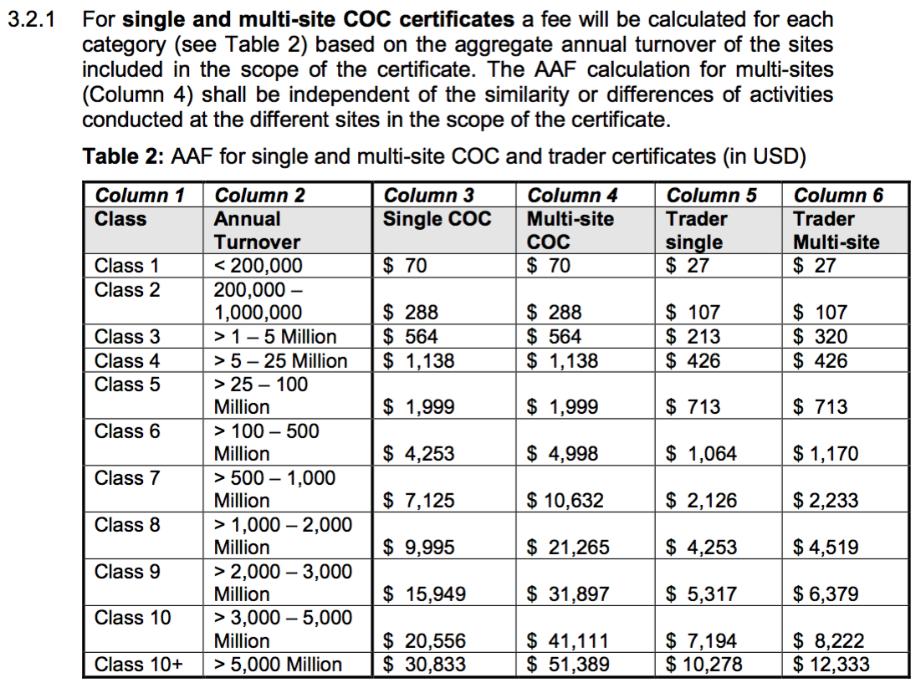

Instructions for the Consultation
Please provide your input on:
- Proposed revised mitigation options for those risk topics that affect or are of interest to you; these are available via Word documents (one per risk topic) shared on the FSC US CW Regional Meetings web site: http://www.engage.us.fsc.org
- New mitigation options that would address gaps in the set of options for a risk topic
- The above Proposed Impact Matrix, considering both the indices and the levels of impact suggested
Please provide your input via:
(Note these methods are preferred, but we will gladly receive comments in any format.)
- The discussion forum that has been established on the above web site
- Comments inserted into, or tracked changes within, the risk topic-specific Word documents and then emailed to standardsforum@us.fsc.org
Deadlines for Comments:
- Feedback on the mitigation options is due to FSC US by Wednesday, October 10th (COB), unless otherwise noted in the individual documents.
- Feedback on the Proposed Impact Matrix is also due to FSC US by Wednesday, October 10th (COB).

Next Steps
- FSC US staff will revise the sets of mitigation options based upon input received, and again with consideration of the shared criteria.
- FSC US Board Members will be asked to review and endorse the sets of mitigation options, unless they find evidence that the options presented could result in a critical fail of the system in the US.
- FSC US will share final sets of mitigation options in late October/Early November, which should align with approval of the FSC US Controlled Wood National Risk Assessment (with the possible exception of Category 4 (Conversion), for which we continue to work on developing an alternative control measure for companies that have more specific information about the origins of the materials they receive).

Annex A: Central Themes Matrix

CW REGIONAL MEETING | SPECIFIED RISK TOPIC | CENTRAL THEME | Education/Outreach | Research/Mapping | Conservation Initiatives | Planning | Implement Mgmt Activities | Staff/Forester Training | Landowner Incentives | Direct Influence | BMP Enforcement/Monitoring | Cape Fear Arch Cons. Collab.
Asheville | Central Appalachian CBA |  | X | X | X |  |  |  |  | X | X
 | Cheoah Bald Salamander |  | X | X | X | X |  |  |  | X
 | Mesophytic Cove Sites |  | X | X |  |  |  | X
Atlanta | Cape Fear Arch CBA |  | X |  | X |  |  |  |  |  |  | X
 | Central Florida CBA |  | X |  | X |  | X
 | Conversion (Atlanta & Portland) |  | X |  | X | X
 | Dusky Gopher Frog |  | X | X |  |  | X
 | Florida Panhandle CBA |  | X | X | X
 | Houston Toad |  | X | X |  |  | X
 | Late-Successional Bot. Hardwoods |  | X | X |  |  | X |  | X
 | Native Longleaf Pine Systems |  | X | X |  | X | X |  | X
 | Patch-Nosed Salamander |  | X | X | X | X
 | Southern Appalachian CBA |  | X | X | X |  |  |  |  | X
Portland | Central California CBA |  | X | X |  | X |  | X
 | Klamath-Siskiyou CBA |  | X | X |  | X | X
 | Lesser Slender Salamander |  | X | X |  |  | X
 | Old Growth Forests |  | X | X |  | X |  | X | X

The following are examples of mitigation options for the Central Themes identified above. It is important to note that while the mitigation options for a particular theme are built on a similar template, each one has been customized for the Specified Risk Topic to which it applies. Therefore, mitigation options for the same Central Theme under different Specified Risk Topics will be similar, but not exactly the same and each should be considered individually for the context in which it is intended to be used.

CENTRAL THEME: Education & Outreach (Central Florida CBA)
Proposed Revised Mitigation Options
The following is offered as an option that could be scaled for any impact level:
Using materials (as described below), and with a desired outcome of engaging landowners, foresters, and loggers within the specified risk area and the Organization’s supply area in conservation of the biodiversity of the pine flatwoods, communicate to audiences (as described below) the social benefits and values of biodiversity in the pine flatwoods, threats from poorly implemented forest management and other activities (i.e. introduction of non-native species, hydrologic alteration, substrate disturbance, conversion to agriculture and pine plantations, altered fire regime, etc), and opportunities for conservation through management that enhances biodiversity and reduces or eliminates these threats.
- Materials: Developed by, or developed in cooperation with, organizations/individuals with expertise in pine flatwoods biodiversity conservation, or FSC US, and delivered in a manner that will be the most effective in achieving the desired outcome of engaging landowners, foresters, and loggers in conservation of pine flatwoods biodiversity, while reflecting the specific context and characteristics of the Organization.
- Audiences: Audiences will reflect the specific context and characteristics of the Organization, but communications should be directed toward those audiences where the communications will be most effective in helping to achieve the desired outcome of engaging landowners, foresters, and loggers within the specified risk area and the Organization’s supply area in conservation of pine flatwoods biodiversity. Depending upon the Organization’s location in the supply chain, communications may be directly with landowners, foresters, or loggers, or through intermediaries such as community members, suppliers, or in collaboration with organizations/individuals already working for conservation of pine flatwoods biodiversity.
The following is offered as an option for Organizations with suppliers that are land managers or that purchase directly from the source forest:
Develop/adapt a procurement policy that reflects the above communications themes and clearly states the expectation that suppliers will promote conservation of pine flatwoods biodiversity and will not provide materials from forests where these HCV were threatened as a result of the forest management activities that produced the forest materials. This will require providing a description of the forest type (as it occurs in the supply area), potential threats from forest management activities, and the kinds of activities that would maintain or enhance pine flatwoods biodiversity in the supply area.
NOTE: Actions to demonstrate policy enforcement and communicate policies on sourcing to suppliers should be audited under the Due Diligence system requirements within the 40-005V3-1 standard section 1.1
CENTRAL THEME: Research & Mapping (Late Successional Bot. Hardwoods)
Proposed Revised Mitigation Option
The following is offered as a two-part option for ‘High Impact’ organizations:
- Engage with and/or provide monetary or in-kind resources to an entity or alliance that is currently conducting, or has the capacity to initiate, research on Late Successional Bottomland Hardwoods topics pertinent to the specified risk area and the Organization’s supply area that will: a) improve understanding of the system and how the High Conservation Value should be defined, b) identify and improve compatible management practices, and/or c) identify occurrences where restoration and maintenance are more likely to be effective; and
- Use the results of the research to improve implementation of another mitigation option.
CENTRAL THEME: Conservation Initiatives (Florida Panhandle CBA)
Proposed Revised Mitigation Option
The following is offered as an option that could be scaled for any impact level:
Engage with and/or provide monetary or in-kind resources to conservation partnerships, organizations or similar entities that are supporting or promoting programs or projects to develop new or augment existing programs that will enhance or conserve aquatic biodiversity in the Apalachicola Bay/River System, with a particular focus on bottomland hardwood forests and forests identified as having higher risk within the portion of the Apalachicola Bay/River System that occurs within areas of the specified risk area and the Organization’s supply area. These entities may include: 1) partnerships including government and/non-government organizations or non-governmental organizations working alone that have active programs/projects to conserve aquatic biodiversity or the forests important for doing so; and/or 2) federal, state and/or local governmental organizations.
CENTRAL THEME: Conservation Planning (Old Growth Forest)
Proposed Revised Mitigation Option
The following is offered as an option that could be scaled for any impact level:
Engage in and/or provide monetary or in-kind resources to conservation planning processes and the implementation of plans that include goals, objectives and/or actions that are intended to achieve conservation of existing Type 1 and Type 2 old growth within the specified risk area and the Organization’s supply area. This may include: federal, state and/or local resource planning and plans; planning and plans for old growth-dependent species; regional planning and plans directly for old growth itself; and/or broad-spectrum regional conservation planning and plans that include old growth conservation.
CENTRAL THEME: Implement Management Activities (Dusky Gopher Frog)
Proposed Revised Mitigation Option
The following is offered as an option that could be scaled for any impact level:
Engage with and/or provide monetary or in-kind resources to conservation organizations or similar entities (as described below) that are facilitating active, on the ground implementation of management activities (as described below) to restore, maintain or enhance Dusky Gopher Frog (DGF) populations, with a goal of long-term DGF conservation within the specified risk area and the Organization’s supply area.
- Conservation Entities/Associations: These may include: non-governmental organizations that have active programs/projects to conserve DGF; federal, state and/or local agencies with natural resource conservation responsibilities; and/or organizations that have active programs/projects focused on conservation of DGF populations.
- Management Activities: These should include efforts to: increase and improve the use of existing Best Management Practices for Native Longleaf Pine Systems that support populations of DGF; increase and improve the use of existing Best Management Practices near ephemeral ponds that support populations of DGF; increase the use of fire as a management tool; restore and maintain native understory communities; and restore and maintain essential hydrology.
CENTRAL THEME: Staff Training (Mesophytic Cove Sites)
Proposed Revised Mitigation Option
The following is offered as an option for Organizations with staff who have direct contact with landowners, loggers, and forest managers and/or who are on-site at the forest material origin prior to harvest:
Ensure staff receive training or the equivalent, with periodic refreshers that include any new information, on identification of Mesophytic Cove Sites (MCS), conservation and social value, management techniques, and treatment and prevention of invasive species. The training or equivalent shall be: a) customized for MCS associated with the forest types that occur within the Organization’s supply area; b) developed by, or developed in cooperation with, organizations/individuals with expertise in conservation of MCS, or FSC US; and c) result in staff having knowledge on these subjects to the extent that they are able to communicate the same content to the landowners and land managers with whom they are working.
CENTRAL THEME: Landowner Incentives (Native Longleaf Pine Systems)
Proposed Revised Mitigation Options
The following is offered as an option that could be scaled for any impact level:
Engage with and/or provide monetary or in-kind resources to conservation organizations or similar entities that are supporting or promoting programs or projects to develop new or augment existing incentive programs for landowner who restore, maintain or enhance existing examples of Native Longleaf Pine Systems (NLPS) within the specified risk area and the Organization’s supply area, or organizations that work to connect landowners with incentives provided by other entities within the same area. These entities may include: non-governmental organizations that have active programs/projects to conserve NLPS; federal, state and/or local governmental organizations; and/or organizations that have active programs/ projects to conserve habitat for species dependent upon NLPS. If the incentive involves a working forest easement, the easement language should include requirements for use of compatible forest management practices that will restore, maintain or enhance the NLPS.
The following is offered as an option for Organizations that have direct contact with the landowners that supply their materials:
Provide an incentive(s) to the landowner for conserving existing high quality or near high quality occurrences of Native Longleaf Pine Systems (NLPS); or facilitate the landowner’s access to incentives provided by other entities that will conserve the existing high quality or near high quality occurrences of NLPS.
CENTRAL THEME: Direct Influence (Southern Appalachians CBA)
Proposed Mitigation Options
The following are offered as options for Organizations that purchase directly from the source forest, or with suppliers that do so:
- Engage with a conservation organization or similar entities, or FSC US, to identify landscapes of particular concern related to the risk of receiving non-certified supplies from areas where aquatic biodiversity are threatened by forest management activities, and then communicate this information to suppliers, along with: 1) recommended Best Management Practices that will conserve aquatic biodiversity; and 2) contact information for organizations that may be interested in working with the landowner on conserving the forest in question in a manner that will continue to conserve the aquatic biodiversity.
- Document acceptable implementation of Best Management Practices that conserve aquatic biodiversity for harvests that produce non-certified materials that will be controlled by the Organization.
- Include Best Management Practices that will conserve aquatic biodiversity in harvest plans and/or in contracts made with loggers for harvests that produce non-certified materials that will be controlled by the Organization.
CENTRAL THEME: BMP Enforcement/Monitoring (Central Appalachians CBA)
Proposed Revised Mitigation Option
The following is offered as an option for ‘high impact’ organizations:
The Organization, either individually or in collaboration with other Organizations, or through an intermediary entity, establishes and implements a program or process that results in voluntary submission of harvest and BMP implementation data from loggers/landowners within the specified risk area and the Organization’s supply area to the State agency responsible for this data collection in a way that is usable by the agency to supplement its established system. This program or process would require independent auditing or sufficient auditing by the state to confirm accuracy of voluntary data regarding BMP implementation and allow the State to demonstrate a very high level of compliance with BMPs, particularly those that address practices for steep slopes and prevention of siltation, throughout the specified risk area and the Organization’s supply area and, therefore, demonstrate a low risk of the Organization receiving supplies from areas where the aquatic biodiversity was threatened by forest management activities.
CENTRAL THEME: Cape Fear Arch Conservation Collaboration (Cape Fear Arch CBA)
Proposed Mitigation Options
The following is offered as an option that could be scaled for any impact level:
Participate in Cape Fear Arch Conservation Collaboration meetings and help to promote their objective of enhancing cooperation and communication regarding regional conservation issues within the specified risk area and the Organization’s supply area.

